EST TABLE OF COLORED PART
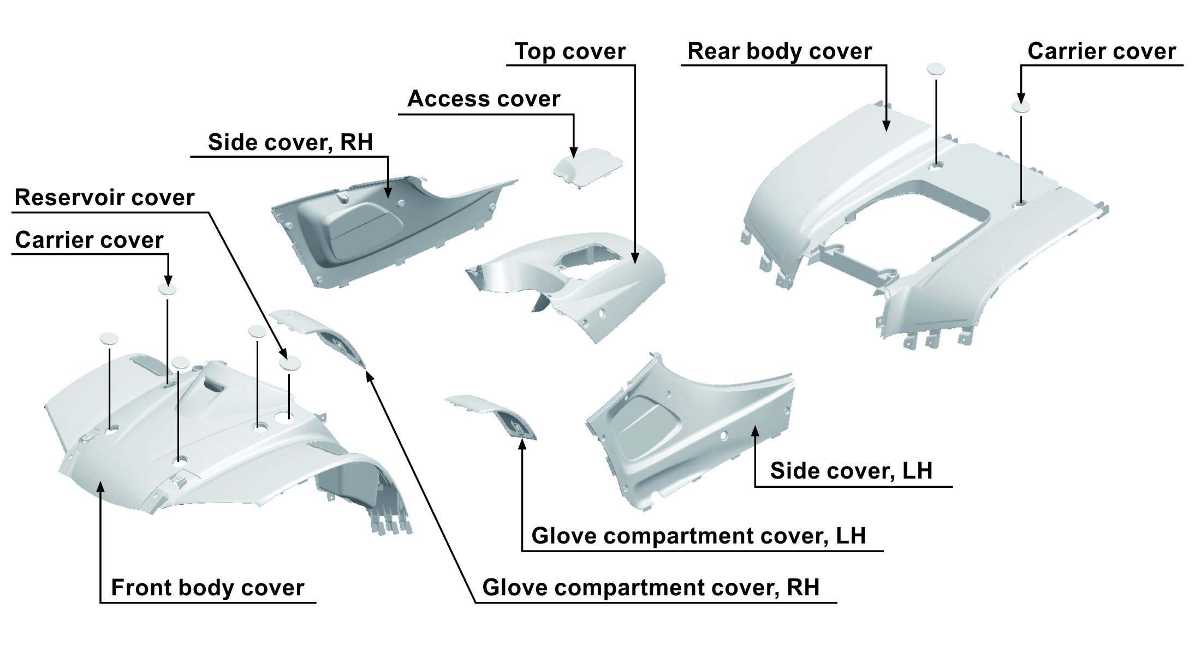

TABLE OF COLORED PART（BLADE 1000 for EPS）2015
ITEM  NO. | CODE | A | B
ITEM  NO. | Basic Color | Titanium Brown | Gentry Gray
ITEM  NO. | Description | TN | YG
21 | Front body cover, With Emblem | 512465TNFR | 512465YGFR
21 | Front body cover | 512465TN | 512465YG
21 | Emblem | 518287TN | 518287TN
21 | Emblem | 518280TN | 518280TN
21 | Glove compartment cover, LH | 512421TN | 512421YG
21 | Glove compartment cover, RH | 512422TN | 512422YG
21 | Carrier cover | 512425TN | 512425YG
21 | Reservoir cover | 512424TN | 512424YG
22 | Access cover | 512592TN | 512592YG
22 | Top cover, With Emblem | 512591TNF3 | 512591YGF3
22 | Top cover | 512591TN | 512591YG
22 | Emblem | 518281TN | 518281TN
22 | Emblem | 518284TN | 518284TN
22 | Side cover, LH, With Emblem | 512583BTNLAG | 512583BYGLAG
22 | Side cover, LH | 512583BTN | 512583BYG
22 | Emblem | 518282TN | 518282TN
22 | Emblem | 518283TN | 518283TN
22 | Emblem | 518288TN | 518288TN
22 | Side cover, RH, With Emblem | 512587ATNRAG | 512587AYGRAG
22 | Side cover, RH | 512587ATN | 512587AYG
22 | Emblem | 518285TN | 518285TN
22 | Emblem | 518286TN | 518286TN
22 | Emblem | 518288TN | 518288TN
23 | Rear body cover | 514498MTN | 514498MYG
23 | Carrier cover | 512425TN | 512425YG

-1-
EST TABLE OF COLORED PART

TABLE OF COLORED PART（BLADE 1000 for EPS）2015
ITEM  NO. | CODE | A | B | C
ITEM  NO. | Basic Color | Orange | White | Silver Gray
ITEM  NO. | Description | OR | WH | SG
21 | Front body cover, With Emblem | 512465ORFP | 512465WHFP | 512465SGFP
21 | Front body cover | 512465OR | 512465WH | 512465SG
21 | Emblem | 518279RD | 518279RD | 518279RD
21 | Emblem | 518280RD | 518280RD | 518280RD
21 | Glove compartment cover, LH | 512421OR | 512421WH | 512421SG
21 | Glove compartment cover, RH | 512422OR | 512422WH | 512422SG
21 | Carrier cover | 512425OR | 512425WH | 512425SG
21 | Reservoir cover | 512424OR | 512424WH | 512424SG
22 | Access cover | 512592OR | 512592WH | 512592SG
22 | Top cover, With Emblem | 512591ORF1 | 512591WHF1 | 512591SGF1
22 | Top cover | 512591OR | 512591WH | 512591SG
22 | Emblem | 518281RD | 518281RD | 518281RD
22 | Emblem | 518284RD | 518284RD | 518284RD
22 | Side cover, LH, With Emblem | 512583BORLAC | 512583BWHLAC | 512583BSGLAC
22 | Side cover, LH | 512583BOR | 512583BWH | 512583BSG
22 | Emblem | 518282RD | 518282RD | 518282RD
22 | Emblem | 518283RD | 518283RD | 518283RD
22 | Emblem | 518288RD | 518288RD | 518288RD
22 | Side cover, RH, With Emblem | 512587AORRAC | 512587AWHRAC | 512587ASGRAC
22 | Side cover, RH | 512587AOR | 512587AWH | 512587ASG
22 | Emblem | 518285RD | 518285RD | 518285RD
22 | Emblem | 518286RD | 518286RD | 518286RD
22 | Emblem | 518288RD | 518288RD | 518288RD
23 | Rear body cover | 514498MOR | 514498MWH | 514498MSG
23 | Carrier cover | 512425OR | 512425WH | 512425SG

-2-
EST TABLE OF COLORED PART

TABLE OF COLORED PART（BLADE 1000 for EPS）2015
ITEM  NO. | CODE | D | E
ITEM  NO. | Basic Color | Red | Black
ITEM  NO. | Description | RD | BL
21 | Front body cover, With Emblem | 512465RDFP | 512465BLFQ
21 | Front body cover | 512465RD | 512465BL
21 | Emblem | 518279RD | 518279BL
21 | Emblem | 518280RD | 518280BL
21 | Glove compartment cover, LH | 512421RD | 512421BL
21 | Glove compartment cover, RH | 512422RD | 512422BL
21 | Carrier cover | 512425RD | 512425BL
21 | Reservoir cover | 512424RD | 512424BL
22 | Access cover | 512592RD | 512592BL
22 | Top cover, With Emblem | 512591RDF1 | 512591BLF2
22 | Top cover | 512591RD | 512591BL
22 | Emblem | 518281RD | 518281BL
22 | Emblem | 518284RD | 518284BL
22 | Side cover, LH, With Emblem | 512583BRDLAC | 512583BBLAD
22 | Side cover, LH | 512583BRD | 512583BBL
22 | Emblem | 518282RD | 518282BL
22 | Emblem | 518283RD | 518283BL
22 | Emblem | 518288RD | 518288RD
22 | Side cover, RH, With Emblem | 512587ARDRAC | 512587ABLRAD
22 | Side cover, RH | 512587ARD | 512587ABL
22 | Emblem | 518285RD | 518285BL
22 | Emblem | 518286RD | 518286BL
22 | Emblem | 518288RD | 518288RD
23 | Rear body cover | 514498MRD | 514498MBL
23 | Carrier cover | 512425RD | 512425BL

-3-
EST TABLE OF COLORED PART

TABLE OF COLORED PART（BLADE 1000）2015
ITEM  NO. | CODE | A | B | C
ITEM  NO. | Basic Color | Orange | White | Silver Gray
ITEM  NO. | Description | OR | WH | SG
21 | Front body cover, With Emblem | 512465ORFP | 512465WHFP | 512465SGFP
21 | Front body cover | 512465OR | 512465WH | 512465SG
21 | Emblem | 518279RD | 518279RD | 518279RD
21 | Emblem | 518280RD | 518280RD | 518280RD
21 | Glove compartment cover, LH | 512421OR | 512421WH | 512421SG
21 | Glove compartment cover, RH | 512422OR | 512422WH | 512422SG
21 | Carrier cover | 512425OR | 512425WH | 512425SG
21 | Reservoir cover | 512424OR | 512424WH | 512424SG
22 | Access cover | 512592OR | 512592WH | 512592SG
22 | Top cover, With Emblem | 512591ORF1 | 512591WHF1 | 512591SGF1
22 | Top cover | 512591OR | 512591WH | 512591SG
22 | Emblem | 518281RD | 518281RD | 518281RD
22 | Emblem | 518284RD | 518284RD | 518284RD
22 | Side cover, LH, With Emblem | 512583BORLAE | 512583BWHLAE | 512583BSGLAE
22 | Side cover, LH | 512583BOR | 512583BWH | 512583BSG
22 | Emblem | 518282RD | 518282RD | 518282RD
22 | Emblem | 518283RD | 518283RD | 518283RD
22 | Side cover, RH, With Emblem | 512587AORRAE | 512587AWHRAE | 512587ASGRAE
22 | Side cover, RH | 512587AOR | 512587AWH | 512587ASG
22 | Emblem | 518285RD | 518285RD | 518285RD
22 | Emblem | 518286RD | 518286RD | 518286RD
23 | Rear body cover | 514498MOR | 514498MWH | 514498MSG
23 | Carrier cover | 512425OR | 512425WH | 512425SG

-4-
EST TABLE OF COLORED PART

TABLE OF COLORED PART（BLADE 1000）2015
ITEM  NO. | CODE | D | E
ITEM  NO. | Basic Color | Red | Black
ITEM  NO. | Description | RD | BL
21 | Front body cover, With Emblem | 512465RDFP | 512465BLFQ
21 | Front body cover | 512465RD | 512465BL
21 | Emblem | 518279RD | 518279BL
21 | Emblem | 518280RD | 518280BL
21 | Glove compartment cover, LH | 512421RD | 512421BL
21 | Glove compartment cover, RH | 512422RD | 512422BL
21 | Carrier cover | 512425RD | 512425BL
21 | Reservoir cover | 512424RD | 512424BL
22 | Access cover | 512592RD | 512592BL
22 | Top cover, With Emblem | 512591RDF1 | 512591BLF2
22 | Top cover | 512591RD | 512591BL
22 | Emblem | 518281RD | 518281BL
22 | Emblem | 518284RD | 518284BL
22 | Side cover, LH, With Emblem | 512583BRDLAE | 512583BBLAF
22 | Side cover, LH | 512583BRD | 512583BBL
22 | Emblem | 518282RD | 518282BL
22 | Emblem | 518283RD | 518283BL
22 | Side cover, RH, With Emblem | 512587ARDRAE | 512587ABLRAF
22 | Side cover, RH | 512587ARD | 512587ABL
22 | Emblem | 518285RD | 518285BL
22 | Emblem | 518286RD | 518286BL
23 | Rear body cover | 514498MRD | 514498MBL
23 | Carrier cover | 512425RD | 512425BL

-5-
EST (EPS) TABLE OF LABEL
Label | Drawing | Description
 | 518287TN | Emblem, Front body cover.
 | 518280TN | Emblem, Front body cover.
 | 518281TN | Emblem, Top cover.
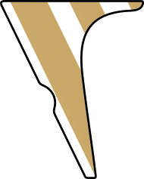 | 518282TN | Emblem, Side cover, LH.
 | 518293TN | Emblem, Side cover, LH.
 | 518284TN | Emblem, Top cover.
 | 518285TN | Emblem, Side cover, RH.
 | 518294TN | Emblem, Side cover, RH.

I
EST (EPS) TABLE OF LABEL
Label | Drawing | Description
 | 518279RD  518279BL | Emblem, Front body cover.
 | 518280RD  518280BL | Emblem, Front body cover.
 | 518281RD  518281BL | Emblem, Top cover.
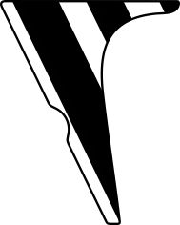 | 518282RD  518282BL | Emblem, Side cover, LH.
 | 518283RD  518283BL | Emblem, Side cover, LH.
 | 518284RD  518284BL | Emblem, Top cover.
 | 518285RD  518285BL | Emblem, Side cover, RH.
 | 518286RD  518286BL | Emblem, Side cover, RH.
 | 518288RD | Emblem, Side cover, (LH/RH).

I
EST TABLE OF LABEL
Label | Drawing | Description
 | 518279RD  518279BL | Emblem, Front body cover.
 | 518280RD  518280BL | Emblem, Front body cover.
 | 518281RD  518281BL | Emblem, Top cover.
 | 518282RD  518282BL | Emblem, Side cover, LH.
 | 518283RD  518283BL | Emblem, Side cover, LH.
 | 518284RD  518284BL | Emblem, Top cover.
 | 518285RD  518285BL | Emblem, Side cover, RH.
 | 518286RD  518286BL | Emblem, Side cover, RH.

II

